Software Requirements Specification
for
Railway seat and services reservation and Tracking
Version 1.0 approved
Prepared by Dharti Patel, Basavraj Jaliminche, Zarana Gohil
Azure Solution
2nd March 2022
Table of Contents
Table of Contents ii
Revision History ii
1. introduction 1
1.1 Purpose 1
1.2 Project Scope 1
1.3 References 1
2. Overall Description 2
2.1 Product Features 2
2.2 User Classes and Characteristics 3
2.3 Operating Environment 3
3. System Features 4
3.1 Booking and Scheduling features 5
3.2 Services and Features of Application 9
4. External Interface Requirements 10
4.1 User Interfaces 10
4.2 Hardware Interfaces 10
4.3 Software Interfaces (Possibility optional) 11
5. Other Nonfunctional Requirements 12
5.1 Performance Requirements 12
5.2 Safety Requirements 12
5.3 Security Requirements 12
5.4 Software Quality Attributes 13
6. Other Requirements (This section is Optional, if you have included all the needed requirements in the Functional and Non-Functional sections) 13

Introduction

Purpose
The purpose of this document is to give a detailed description of the requirements for the “Railway Tracking System” software. It will illustrate the purpose and complete declaration for the features of existing system. It will also explain enhanced features of existing features. This document is primarily intended to be proposed to a stakeholder for its approval and a reference for developing the first version of the system for the development team.

Project Scope
The “Railway Tracking System” is a web and mobile application which helps people to find the closest train based on the user’s current position and other specification like where they want to travel and when they want to travel. The application should be free to download from either a mobile phone application store or similar services.

When user give input for their required information, system will provide all the information of that train as per user’s given inputs. There will be filter option available for time, day selection as well as from location and to location (city or state) they want to travel, so they can easily find their travel options.

Moreover, they are additional features like allows user to book a helper for luggage at the time of seat reservation, wheelchair services on station, When, the train is away an hour from your destination application gives you an alert notification, the people who carries their pet along with them, the application provides the user to book a room for pets for their assistance. This all information can provide users using the web-portal or mobile application. This information will act as the bases for the search results displayed to the user.

References
IEEE. IEEE Std 830-1998 IEEE Recommended Practice for Software Requirements Specifications. IEEE Computer Society, 1998.

Overall Description

Product Features
The new online reservation system maintains the database centrally giving the clients their information required from anywhere in the world whenever required. This system requires the use of API through which it interacts the data from a central database monitor all the data exchanges that are made at the client side to it and updates it automatically. Through online reservation system customer is able to book & purchase a ticket thus saving time money for the customer
and a railway/agent. As the information is stored centrally the customer never loses his ticket as in the existing system.

Generate Train Reports
Train Management

Generate Booking Reports
Booking Management

Railway Enquiry System

Ticket Management
Generate Ticket Report

Route Management
Generate Route Reports

Check User Login Details
Login Management

Generate System Finance Reports
Rate and Payment Management

User Classes and Characteristics

Users of the system should be able to retrieve train information between two given cities with the given date/time of travel from the database. A route from city A to city B is a sequence of connecting trains from A to B such that: a) there are at most two connecting stops, excluding the starting city and destination city of the trip, b) the connecting time is between one to two hours. The system will support two types of user privileges, Customer, and Employee. Customers will have access to customer functions, and the employees will have access to both customer and Train management functions.

Make a new reservation

One-way

Round-Trip

Multi-city

Flexible Date/time

Confirmation

Cancel an existing reservation

Add additional Services

The customer should be able to do the following functions

CUSTOMER FUNCTIONS.

Get all customers who have seats reserved on a given flight.

Get all flights for a given airport.

View flight schedule.

Get all flights whose arrival and departure times are on time/delayed.

Calculate total sales for a given flight.

The Employee should have following management functionalities:

ADMINISTRATIVE

Add/Delete a Train Reservation

Add a new Reservation

Update fare for tickets.

Add a new Train timing if available.

Update departure/arrival times for train

Each train has a limited number of available seats. There are a number of trains which depart from or arrive at different cities on different dates and time.

Operating Environment
Operating environment for the Railway Tracking system is as listed below.

- distributed database
- client/server system
- Operating system: Windows.
- database: sql+ database
- platform: vb.net/Java/PHP

System Features

Booking and Scheduling features
3.1.1 Description and Priority
The online railway reservation and tracking system maintain information on trains, classes of seats, personal preferences, prices, and bookings. Of course, this project has a high priority because it is very difficult to travel across the states without prior reservations. Moreover, it becomes difficult if there are no services provided for pets, luggage, and wheelchair on-ramps.
3.1.2 Stimulus/Response Sequences
- Search for trains for two travel cities.
- Displays a detailed list of available seats and makes a “Reservation” or Book a ticket on a particular train.
- Cancel an existing Reservation.
- Displays the services and books if required.
- Displays the train route and gives the exact time to wait for the train.

3.1.3 Functional Requirements

In software engineering, a functional requirement defines a function of a software system or component. A function is described as a set of inputs, behavior, and outputs. Functional requirements may include calculations, technical details, data manipulation and processing, and other specific functionality that show how a use case is fulfilled. Typically, a requirements analyst generates functional requirements after building use cases. However, this may have exceptions since software development is an iterative process, and sometimes certain requirements are conceived before the definition of the use case. Both artifacts (use cases documents and requirements documents) complement each other in a bidirectional process. The atypical functional requirement will contain a unique name and number, a summary, and a rationale. This information is used to help the reader understand why the requirement is needed, and to track the requirement through the development of the system. The core of the requirement is the description of the required behavior, which must be a clear and readable description of the required behavior. This behavior may come from organizational or business rules, or it may be discovered through elicitation sessions with users, stakeholders, and other experts within the organization. Software requirements must be clear, correct unambiguous, specific, and verifiable.
Other system features include:

DISTRIBUTED DATABASE:

Distributed database implies that a single application should be able to operate transparently on data that is spread across a variety of different databases and connected by a communication network as shown in below figure.

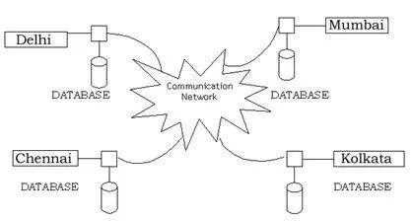

CLIENT/SERVER SYSTEM

The term client/server refers primarily to an architecture or logical division of responsibilities, the client is the application (also known as the front-end), and the server is the DBMS (also known as the back-end).

A client/server system is a distributed system in which,

- Some sites are client sites and others are server sites.
- All the data resides at the server sites.
- All applications execute at the client sites.

USE CASES:

In the Unified Modeling Language (UML), a use case diagram can summarize the details of your system's users (also known as actors) and their interactions with the system. To build one, you'll use a set of specialized symbols and connectors. An effective use case diagram can help your team discuss and represent:

- Scenarios in which your system or application interacts with people, organizations, or external systems

- Goals that your system or application helps those entities (known as actors) achieve

- The scope of your system.
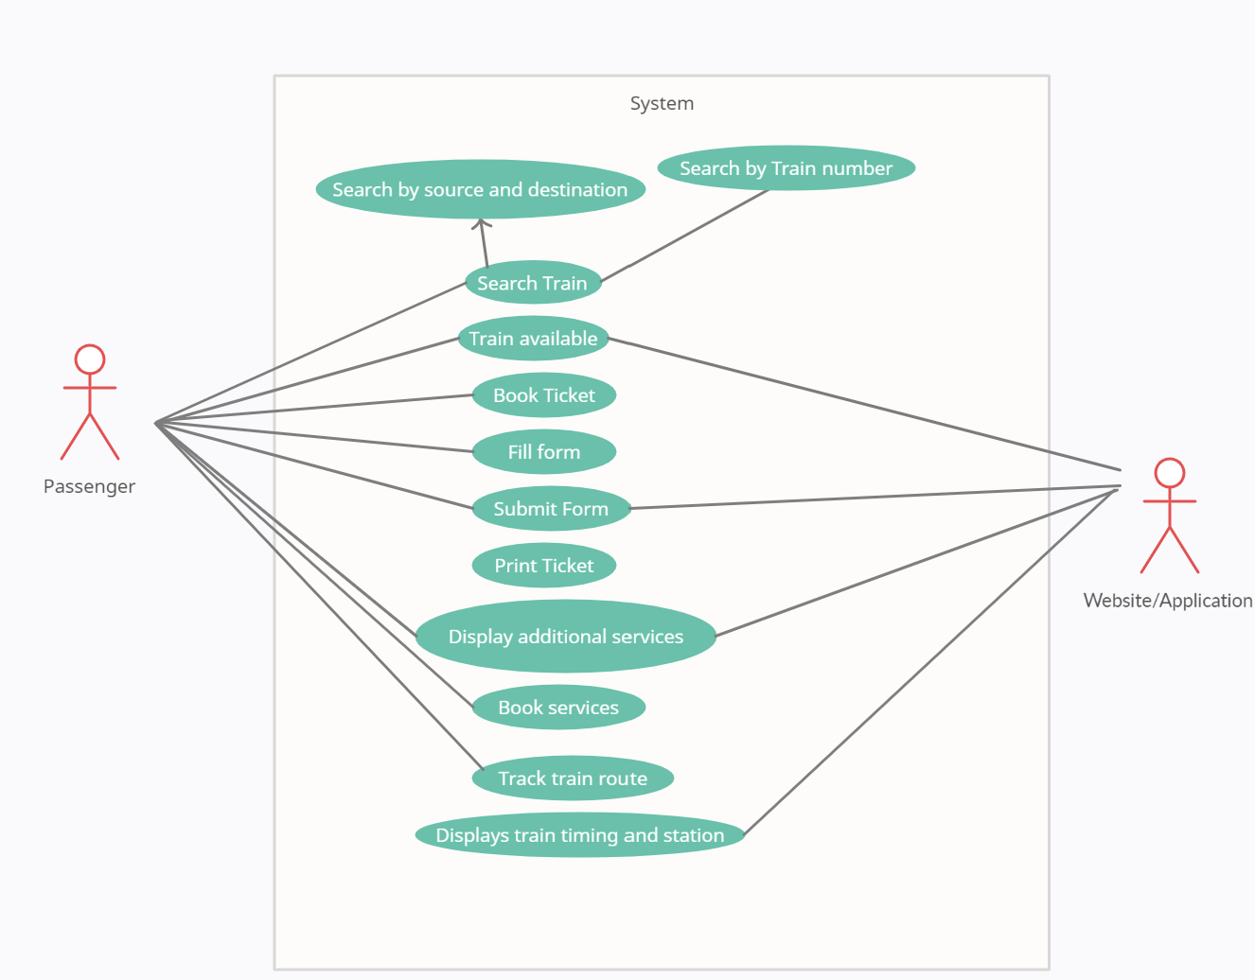
Use case: Ticket availability, reservation, booking, train status
Use case: Ticket cancellation

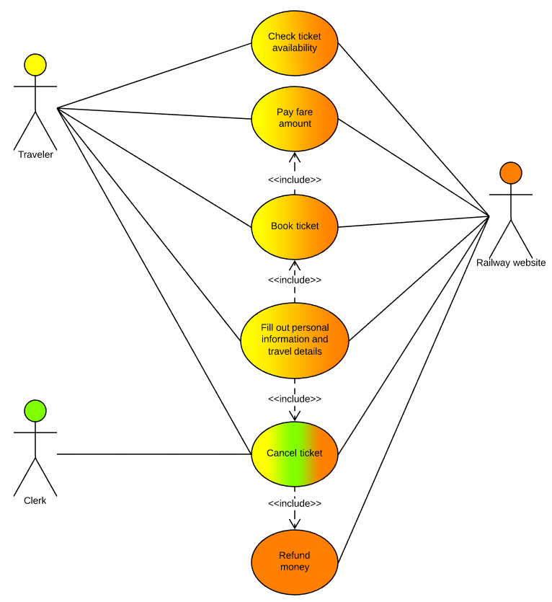

Services and Features of Application
RESERVATION OF TICKET:

REQUEST TIME TABLE: Passenger requests database to display railway timetable.

DISPLAY TIMETABLE: Database displays timetable to the customer.

REQUEST TO RESERVE TICKET: The passenger requests the clerk to reserve his/her ticket.

INPUT DETAILS: Clerk asks customer to enter details for the reservation of ticket.

CALCULATE FARE: The clerk calculates the total fare of the journey according to the number of passengers and tells the customer.

RESERVE TICKET: Ticket is reserved and the customer pays the fare.

REQUEST TO PRINT: Customer requests to print the ticket.

PRINT TICKET: The ticket is been printed and handled by the customer.

CANCELLATION OF TICKET:

REQUEST TO CANCEL TICKET: Customer requests to cancel his/her ticket for which he/she has to give the PNR number.

CANCEL TICKET: Once the PNR number is received, the ticket is canceled

RESERVATION OF SERVICES:

DISPLAY SERVICES: While reserving the seats, the system asks for additional services. This will display services lists.

REQUEST TO RESERVE SERVICE: The passenger adds details to reserve the service.

TRACKING OF TRAINS:

SEARCH TRAIN: The customer inputs details of train.

DISPLAYS ROUTE: The system displays the route of train and also time required to reach to your station.

Feature 1: TRAIN DETAILS:
When customer search the train by entering source and destination details, the system will display train details.

Feature 2: RESERVATION
After checking the available seats, the customer reserves the seat.

Feature 3: BILLING
A bill will be generated after reserving the ticket which includes the details of your seat.

Feature 4: CANCELLATION
If the customer wants to cancel the ticket, the refund will be initiated as per the policy defined.

Feature 5: SERVICES
The system displays the additional services to book.

Feature 6: PERFORMANCE REQUIREMENT
It is available during all 24 hours

Feature 7: SOFTWARE SYSTEM ATTRIBUTES
- Reliable
- Available
- Secure

External Interface Requirements

User Interfaces
The user interface for the software shall be compatible to any browser such as Internet Explorer, Mozilla or Netscape Navigator by which user can access to the system.
The user interface shall be implemented using any tool or software package like Java Applet, MS Front Page, EJB etc.

Hardware Interfaces
The application includes two major hardware components: cellular phones and regular PC's. The cell phones require WAP (wireless application protocol) network protocol, which is already programmed in the latest phones. This is similar to the seven layers of network protocol, except that they are broken down into five protocols. The WAP protocol is able to communicate with the servers known as Gateway servers, which listen to requests made using these phone frequencies. The request is then transmitted to the regular server. Furthermore, the servers respond to these "air" requests and format the data to be displayed on the mini window that is available on the phone. The cellular phone has a processor, which is designed to process a language known as WML (wireless markup language). Therefore, the server formats the data in WML format, and passes these pages to the Gateway servers, which transmits the WML pages to the cellular phones. The processor on these phones then translates the WML into a simplified version of the actual web page.

The second component involves the regular PC’s, which communicate with the server. The server then communicates with the database. The protocol involved between the PC's and the server is the HTTP protocol, which allows communication between the PC's and the Server. The remote PC's, such as someone accessing the ARRS from home using the Internet, are able access the information through the CGI. The requests come in through the HTTP protocol, and using an ODBC the database results are returned and processed using Perl to give an HTML web page. The format of the output is displayed as web pages.

Software Interfaces (Possibility optional)
An Oracle DBMS will be used to manage the database and any changes made to it. Furthermore, the DBMS will make regular backups of the database and generate reports regularly so that they can be accessed by the CRM. The Apache server between the client and the database will handle all communication, and the server will run on a Linux operating system. Furthermore, the HTML pages must be implemented such that they can be displayed on two common browsers: Netscape and Internet Explorer.
Information about the products used for the ARRS:

(1) Name: Oracle
(2) Mnemonic: Oracle
(3) Version Number: 8
(4) Source: Oracle

(1) Name: Linux
(2) Mnemonic: Linux
(3) Version Number: 6.2
(4) Source: Unix

(1) Name: Internet Explorer
(2) Mnemonic: IE
(3) Version Number: 5.00
(4) Source: Microsoft

(1) Name: Netscape Communicator
(2) Mnemonic: Netscape Communicator
(3) Version Number: 4.7
(4) Source: America Online

(1) Name: Apache
(2) Mnemonic: Apache
(3) Version Number: 1.3.14
(4) Source: Apache Software Foundation

Other Nonfunctional Requirements

Performance Requirements
User Requirements | Description of Requirement For Design Environment
Location(s) and Number(s) of Users | Guangzhou, Nanjing, Shanghai
Expected Growth in Number of Users
After 1 Year | 50%
After 2 Years | TBD
After 3 Years | TBD
User Expectation
Interactivity | User expect that it provides a very easy to use graphical user interface
Reliability | For some applications, reliability must be 100% during the application session
Adaptability | Network must adapt to user additions, deletions and changes
Security | Encryption software would be used for Credit Card transactions
Cost / Funding | Less than $250K

Safety Requirements
Extent to which access to software or data by unauthorized people can be controlled The Railway reservation system should not compromise the customer information at any time. The user information will never be sold to other parties and will be kept secure at all times. Users will be authenticated to ensure that no unauthorized users gain access to private information.
Use of Firewall for the application assures the safety of the user data and the application.

Security Requirements
Security:

The system use SSL (secured socket layer) in all transactions that include any confidential customer information. The system must automatically log out all customers after a period of inactivity. The system should not leave any cookies on the customer’s computer containing the user’s password. The system’s back-end servers shall only be accessible to authenticated management.

From a security point of view, authentication will be done by password checking. If correct password has been entered by the user, the user will get further access to the system, otherwise he will have to re-enter the password. The facility to change the password has also been provided but for that the user will have to first enter the old password. The password can be four characters long.

Software Quality Attributes
RELIABILITY: This system must be highly robust. amount of computing resources and code required to perform function extent to which program performs with required precision

• Correctness - extent to which program satisfies specifications, fulfills user’s mission objectives
• Efficiency - Flexibility - effort needed to modify operational program
• Interoperability - effort needed to couple one system with another
• Testability - effort needed to test to ensure performs as intended

RE-USEABILITY: This requirement is present, as this system will interact with the user.
• Extent to which it can be reused in another application
• Effort required to learn, operate, prepare input, interpret the output

PORTABILITY: The Railway reservation system will be developed using HTML and Java so that it can be accessed from any type of system using just a regular web browser. It will also be available to users that have web access on their cellular phones. The system will be tested on all types of hardware before being released to ensure that is it compliant with this requirement.

RESOURCES UTILIZATION: The Railway reservation system will be developed so that it uses all type of functions and fulfill all the requirements of the system it uses the class hierarchy and pre-inbuilt library functions which are completely utilized in the system designing and coding.

STABILITY AND SPEED EFFICIENCY: It should be fast enough to produce the output The RRS system will be considered correct when the CRM approves the prototype presented and agrees that all the functions they require are implemented as stated in the Software Requirements Specification.

MAINTAINABILITY: Effort required to locate and fix an error during operation Time: The project should be completed within the stipulated time period Cost: The cost involved in marketing the project should be less

Other Requirements
Functional
- Every online booking needs to be associated with an account
- One account cannot be associated with multiple users
- Search results should enable users to find the most recent and relevant booking options
- System should enable users to book / pay for their tickets only in a timeboxed manner after tickets being added to the cart
- System should only allow users to move to payment only when mandatory fields such as date, time, location has been mentioned
- System should consider time zone synchronisation when accepting bookings from different time zones
- Booking confirmation should be sent to the user to the specified contact details

Non-Functional
- Use of captcha and encryption to avoid bots from booking tickets
- Search results should populate within acceptable time limits
- User should be helped appropriately to fill in the mandatory fields, in case of invalid input
- System should accept payments via different payment methods, like PayPal, wallets, cards, vouchers, etc.
- System should visually confirm as well as send booking confirmation to the user's contact

